**TASK 23 OUTPUT:**

**1.Displaying employee name whose salary is greater than 2200.**

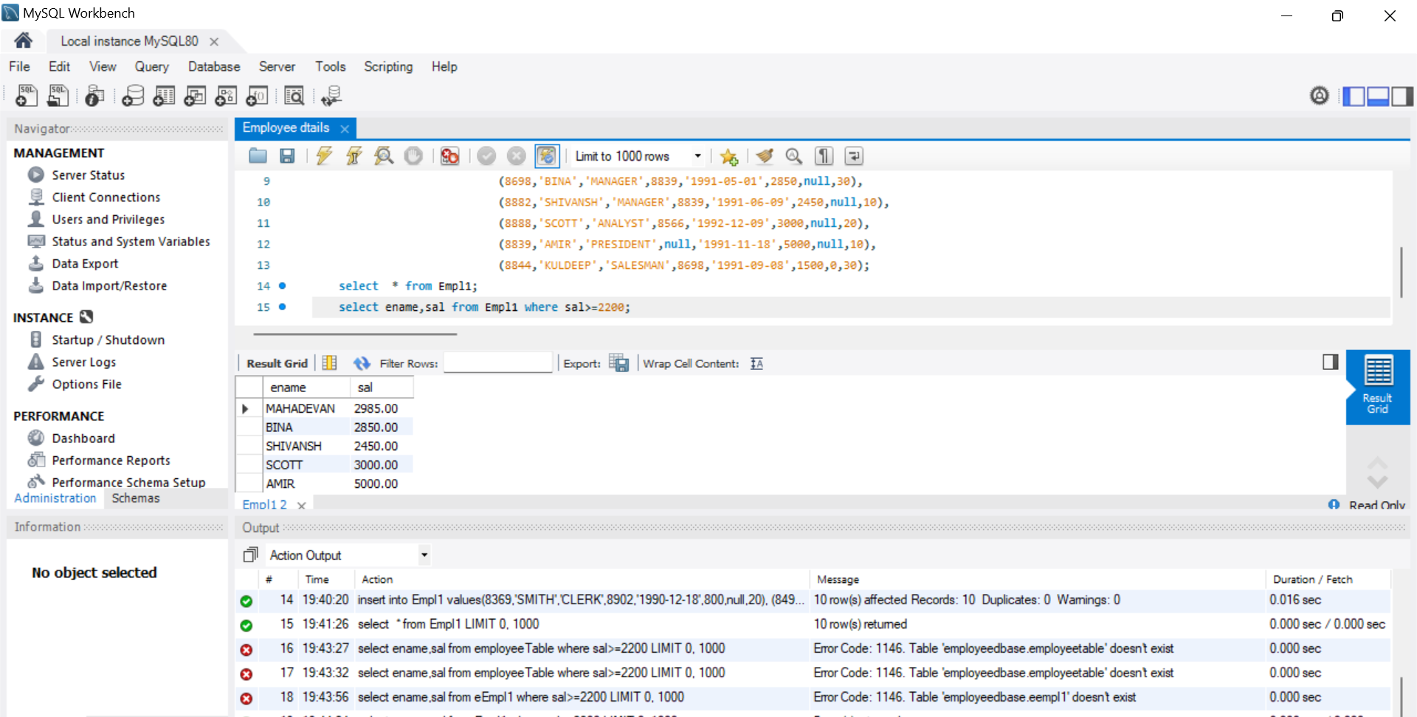

**2.Displaying details of employee who are not getting commission.**

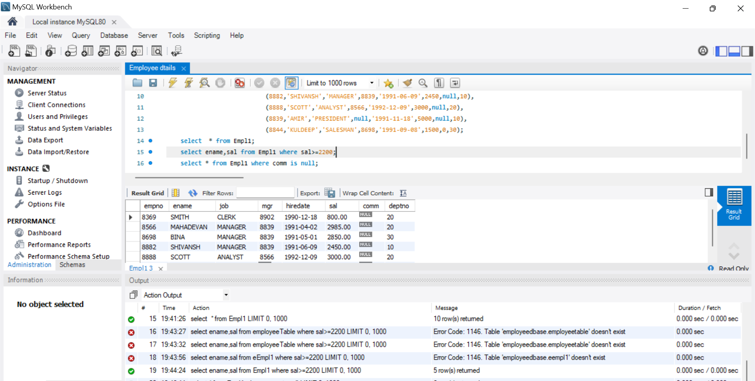

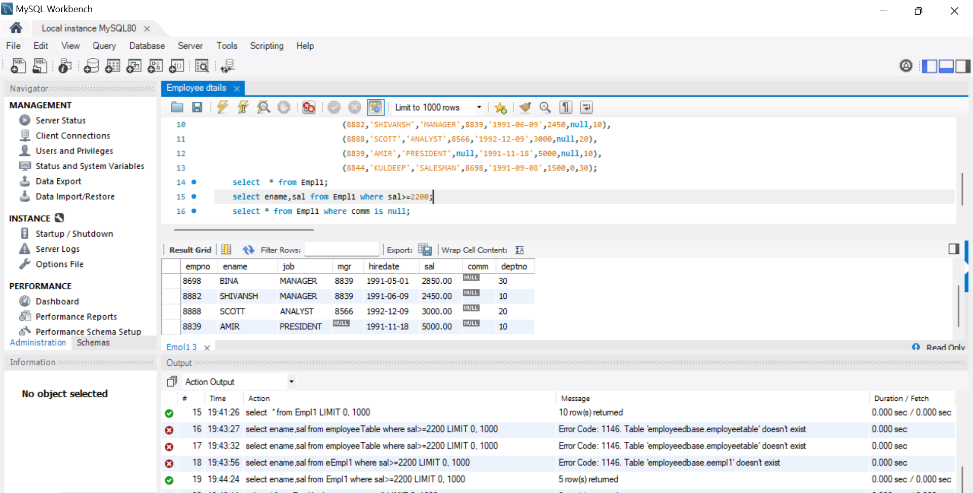

**3. Displaying employee name and salary of employees who don't have salary in the range of 2500 to 4000.**

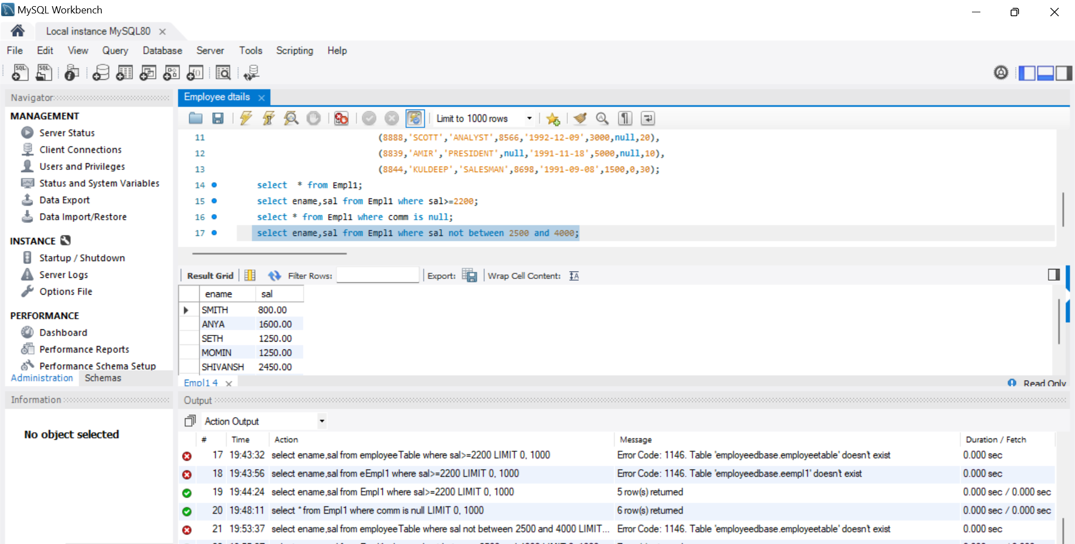

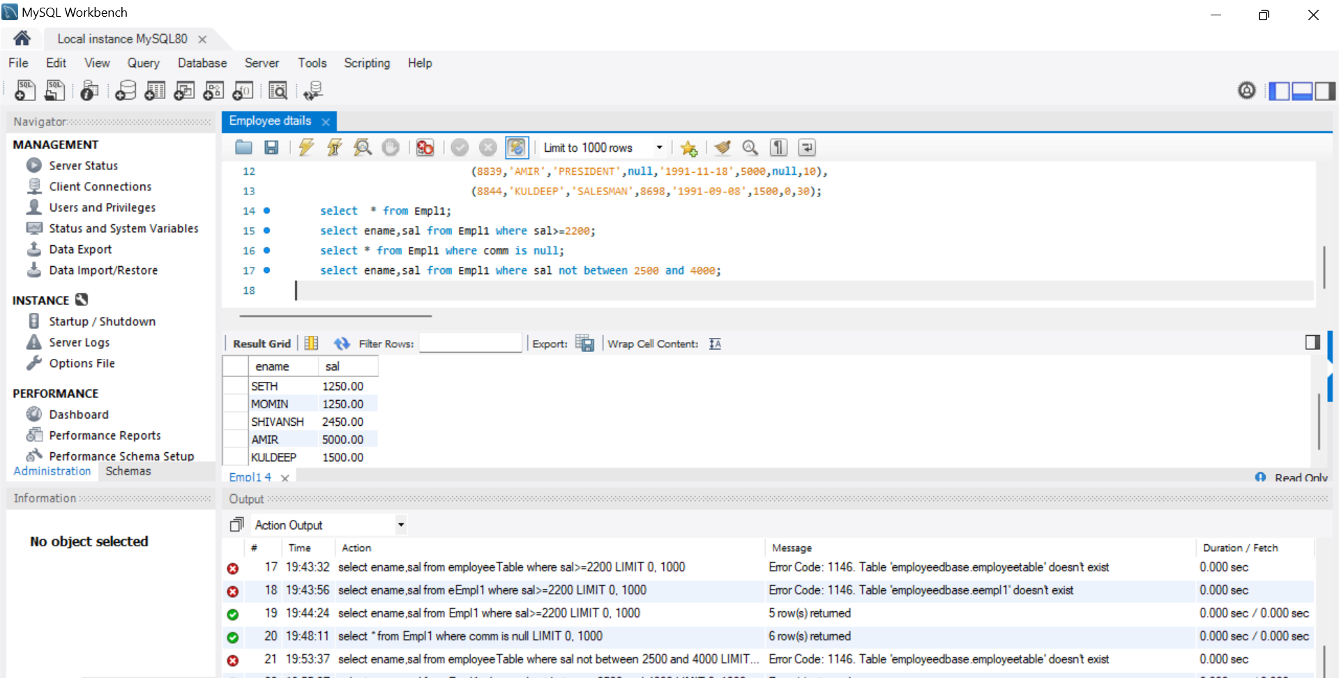

**4. Displaying employee name, job title and salary of employees who don't have a manager.**

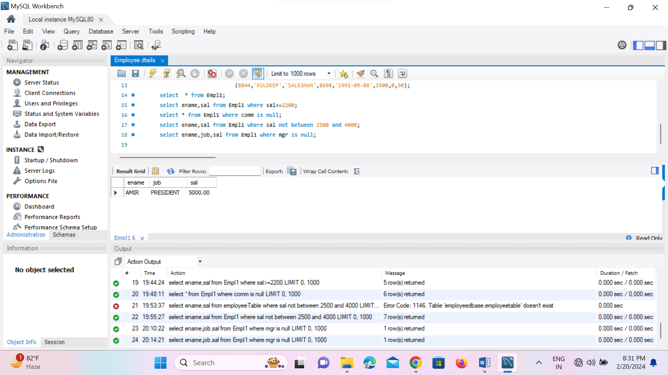

**5.Displaying the employee name whose name contains "A" as third alphabet.**

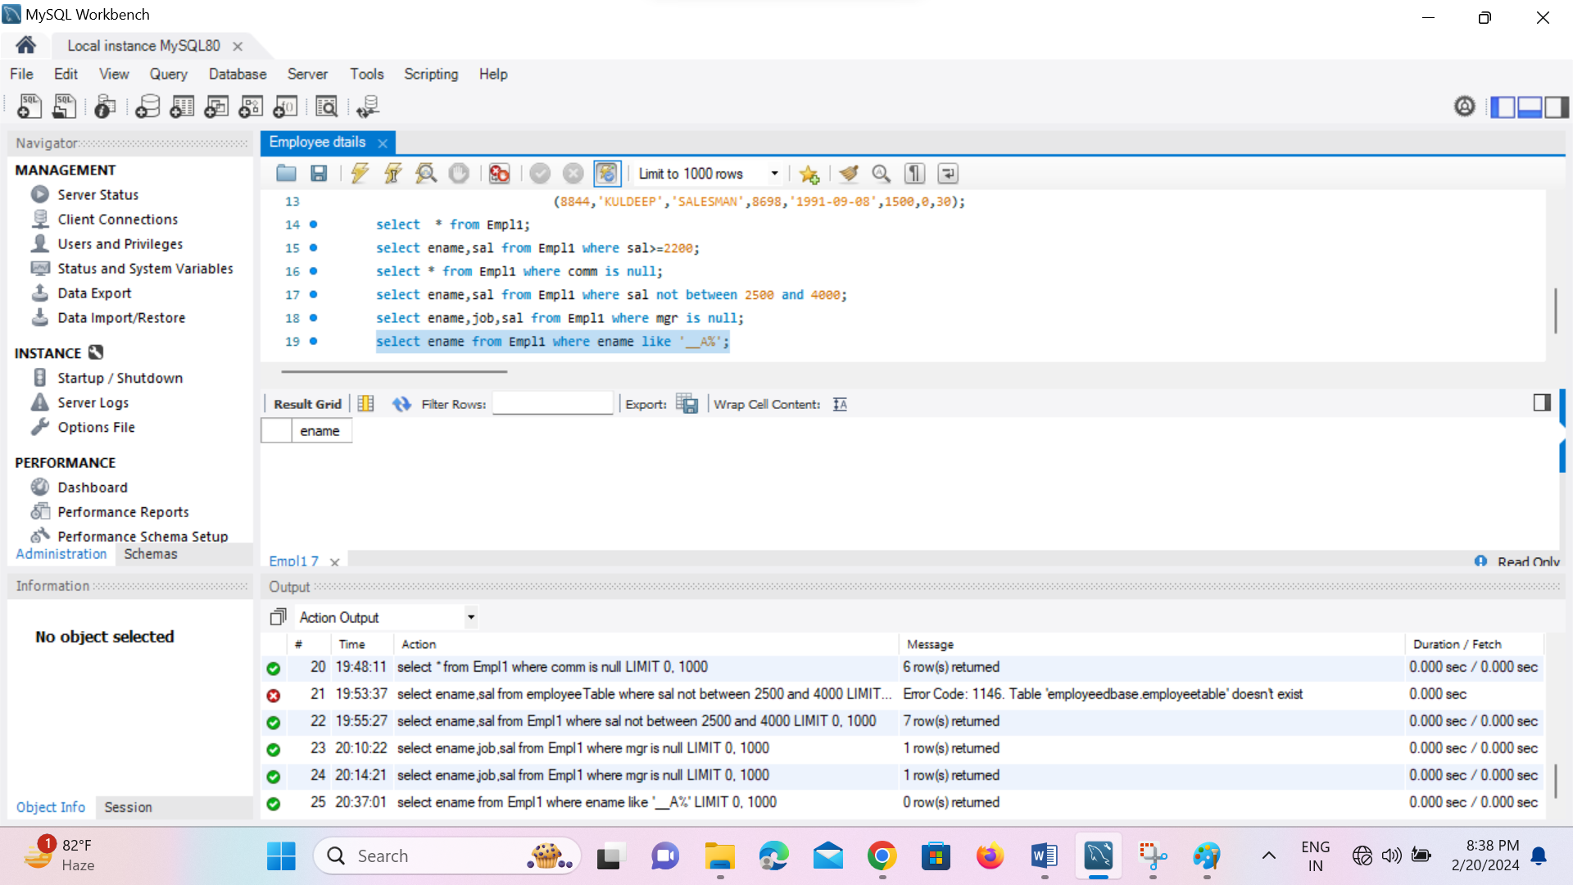

**6.Displaying the employee name whose name contains "T" as the last alphabet.**

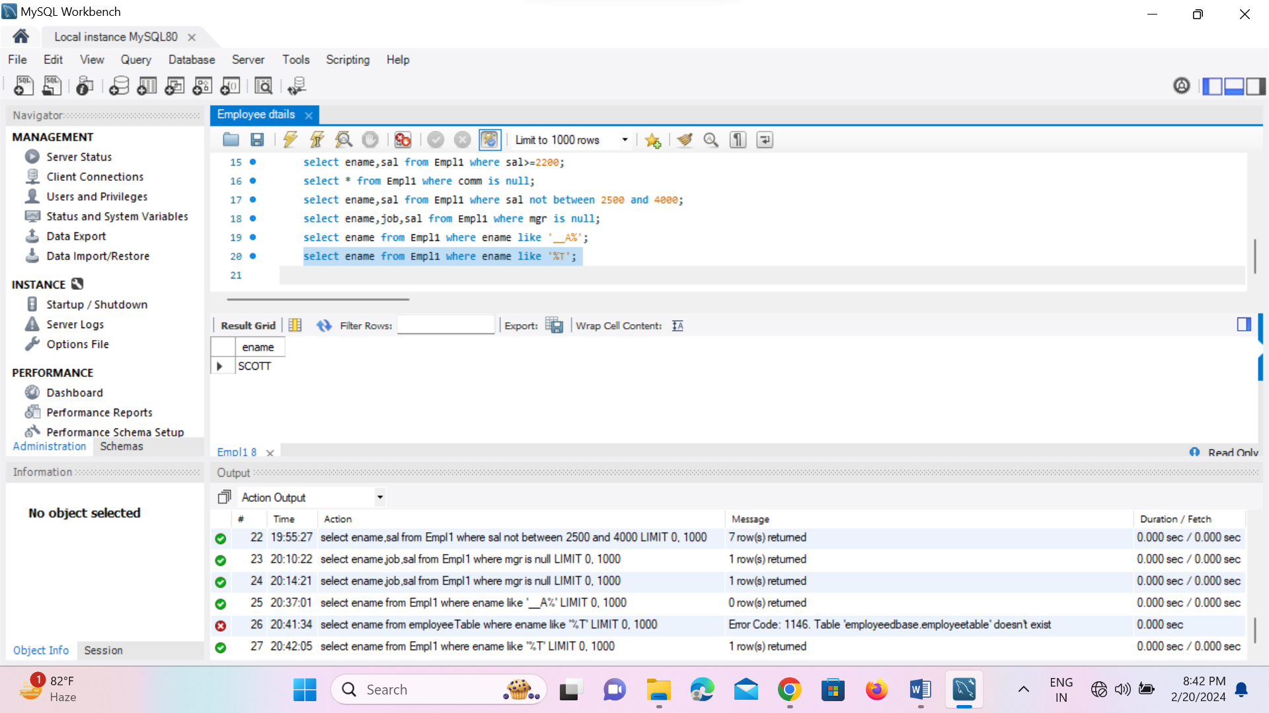

**2.Program for JDBC connectivity and inserting the given data.**

